Name : Arshiya Tabassum A

Superset ID : 6424209

**WEEK 6**

**Create a new React Application with the name “myfirstreact”, Run the application to print “welcome to the first session of React” as heading of that page.**

**Installation :**

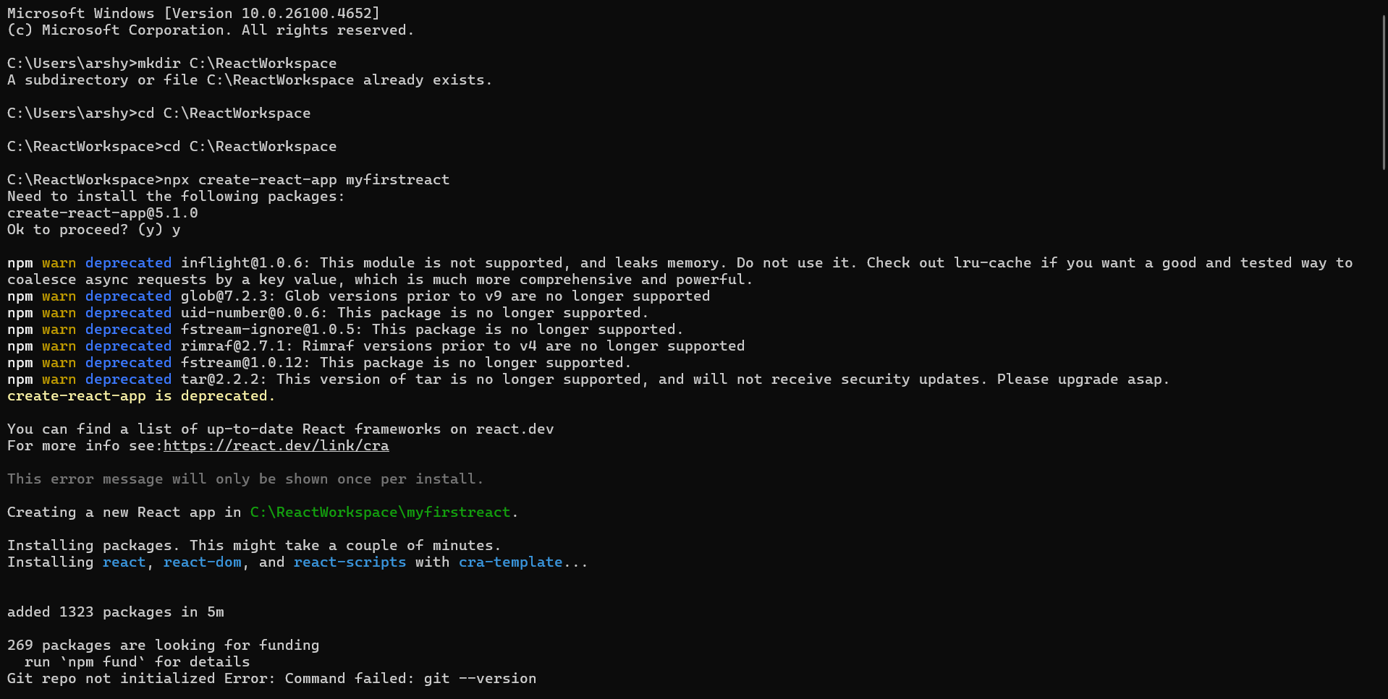

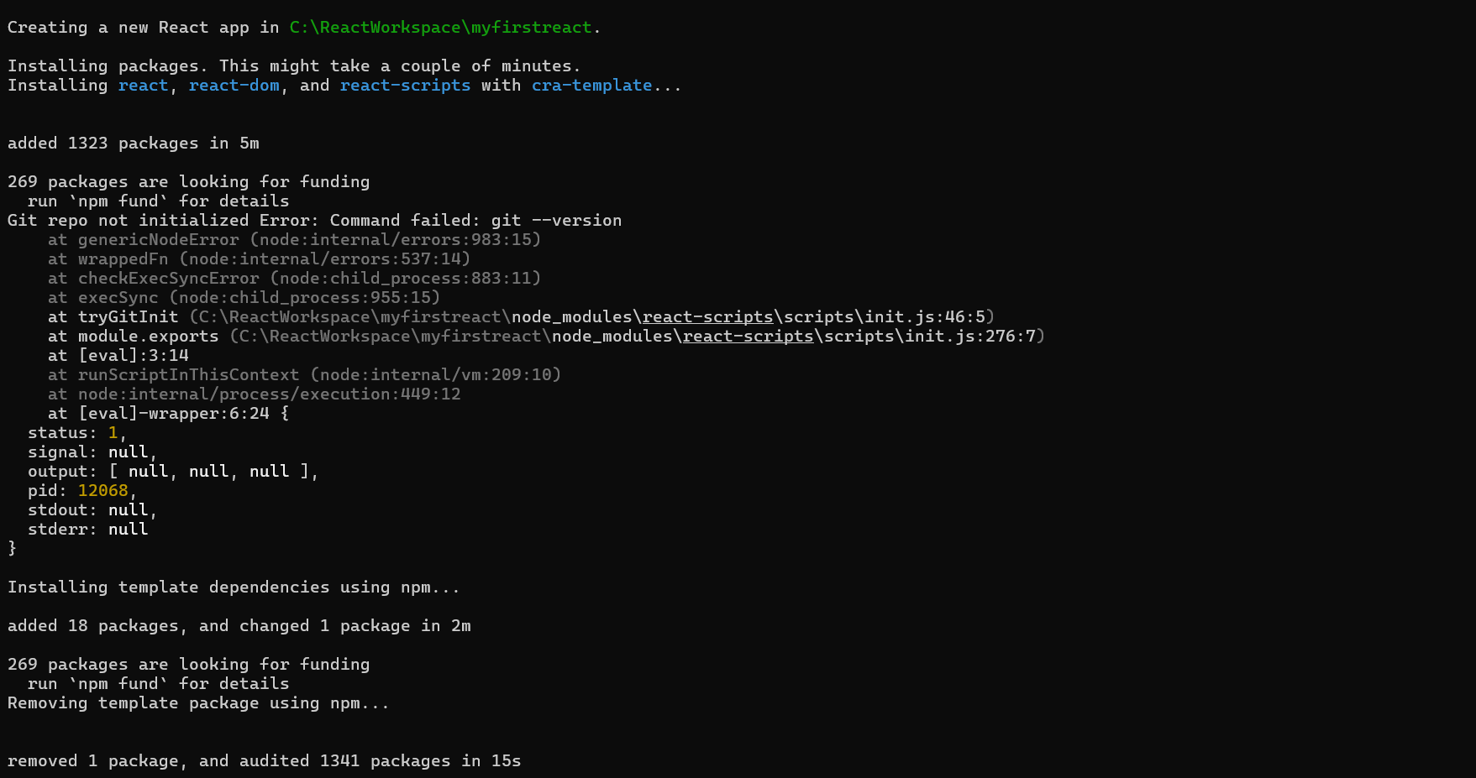

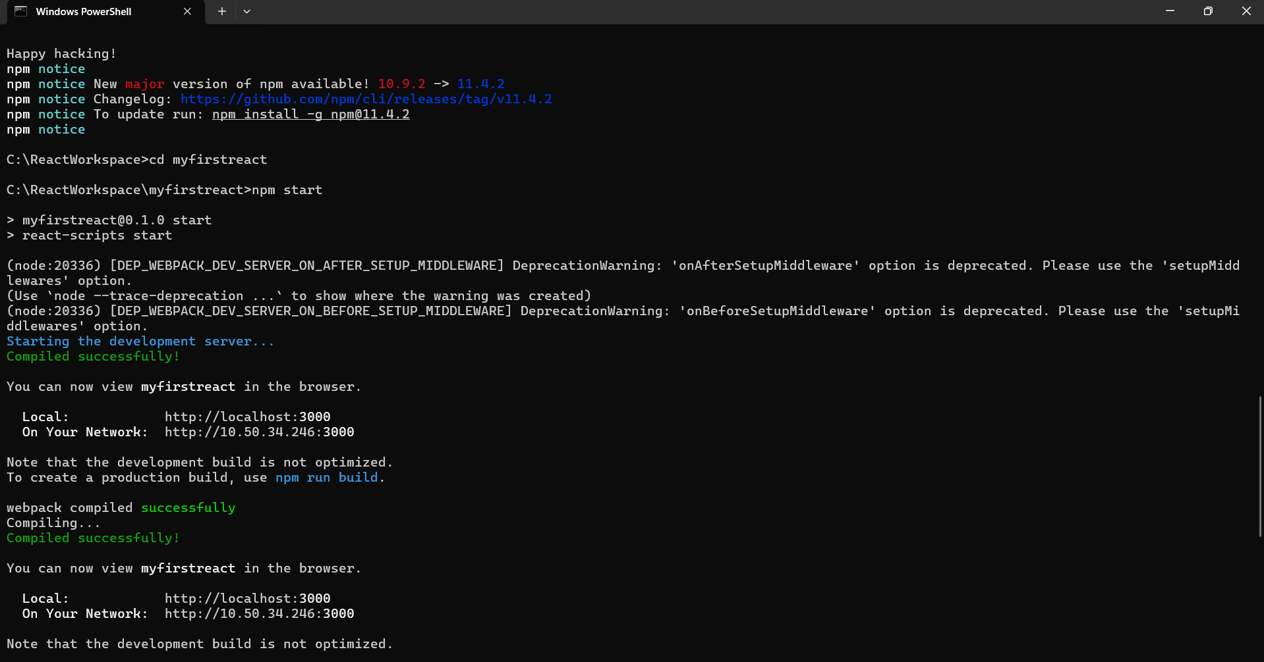

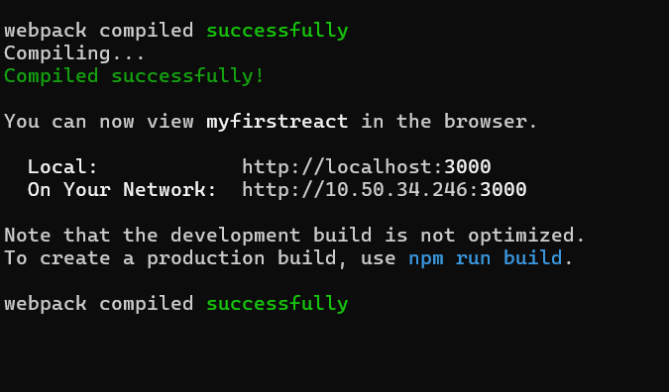

**App.js**

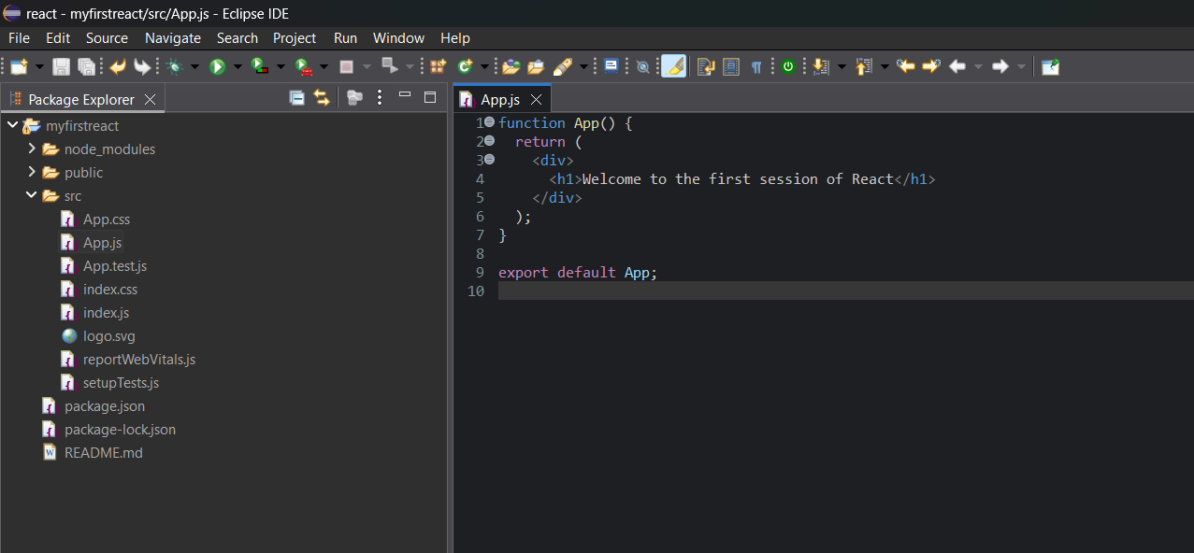

**Output :**

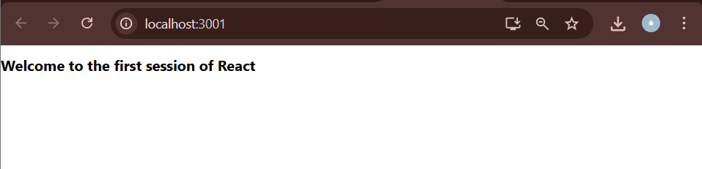

**Create a react app for Student Management Portal named StudentApp and create a component named Home which will display the Message “Welcome to the Home page of Student Management Portal”. Create another component named About and display the Message “Welcome to the About page of the Student Management Portal”. Create a third component named Contact and display the Message “Welcome to the Contact page of the Student Management Portal”. Call all the three components.**

**Installation :**

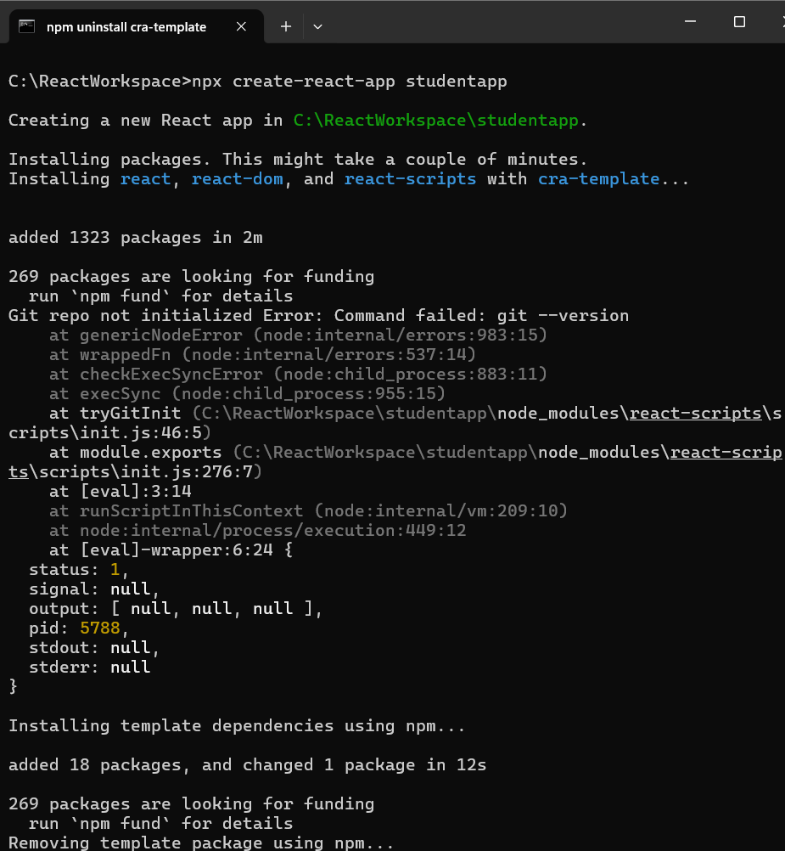

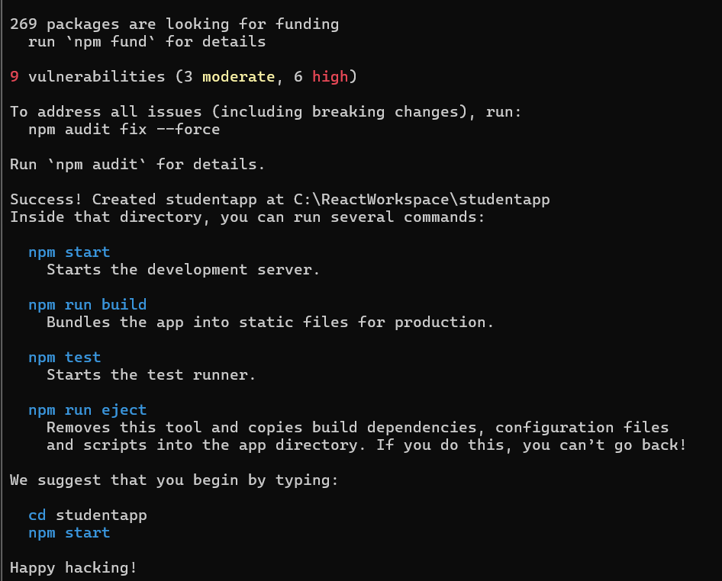

**StudentApp**

**About.js**

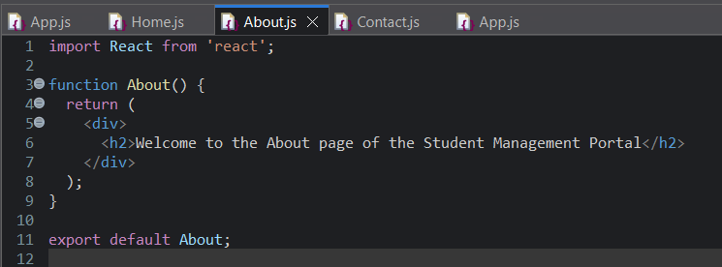

**Contact.js**

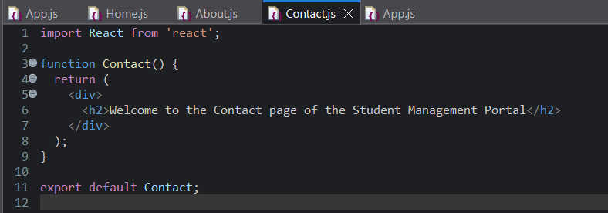

**Home.js**

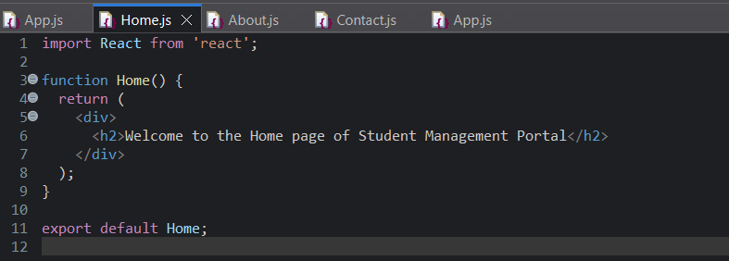

**App.js**

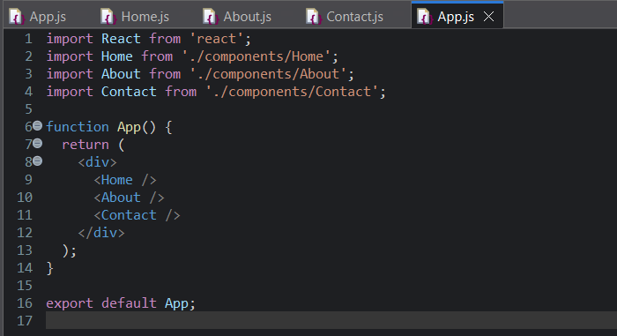

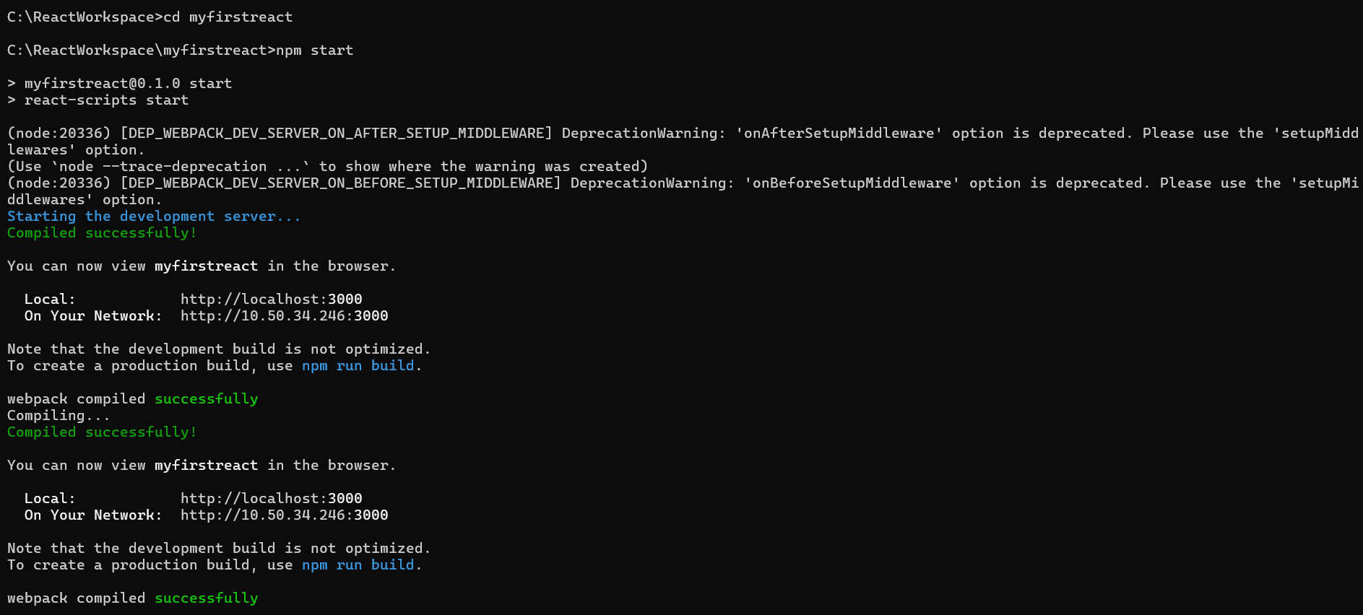

**Output :**

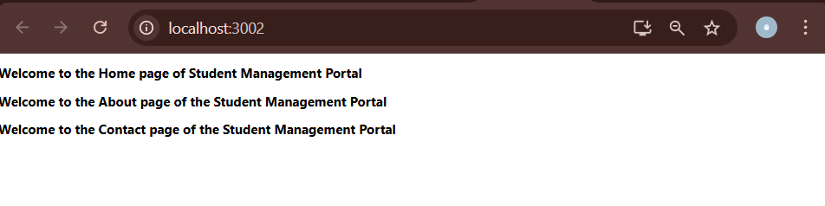

**Create a react app for Student Management Portal named scorecalculatorapp and create a function component named “CalculateScore” which will accept Name, School, Total and goal in order to calculate the average score of a student and display the same.**

**Installation :**

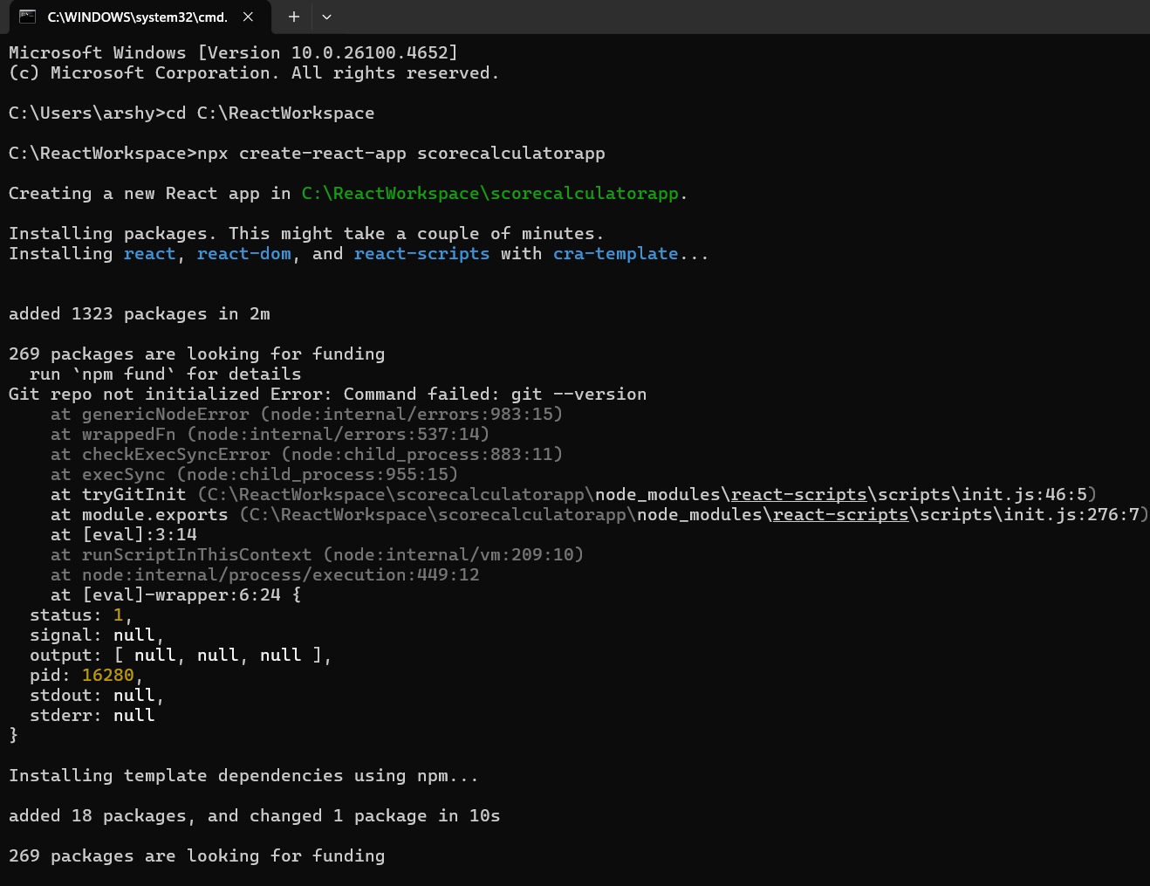

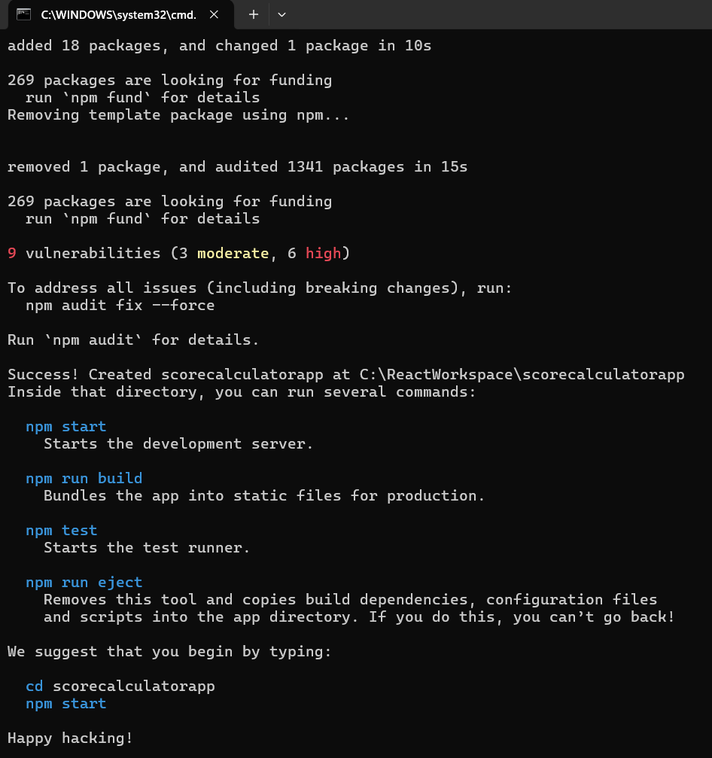

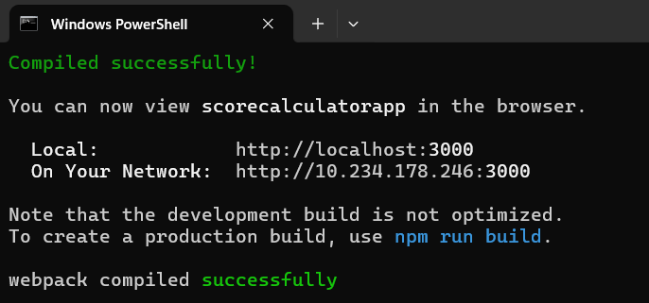

**CalculateScore.js**

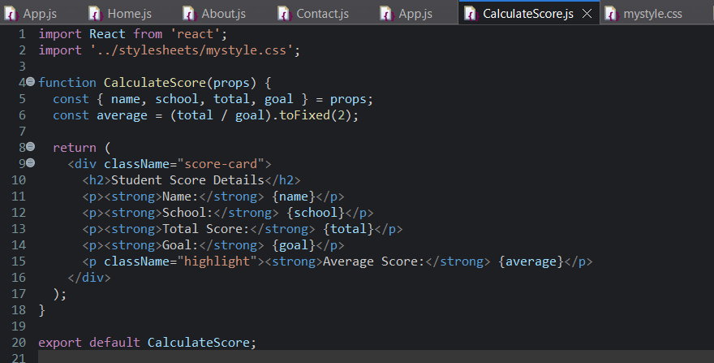

**Mystyle.cs**

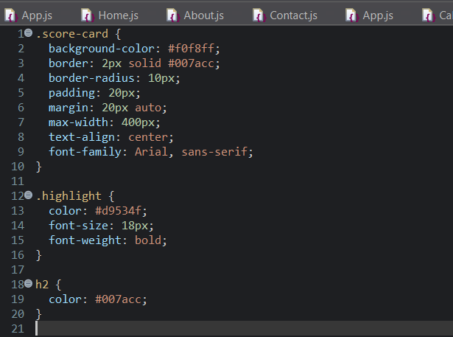

**App.js**

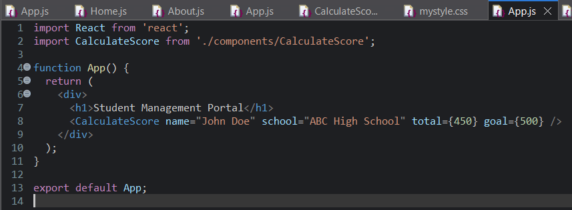

**Output :**

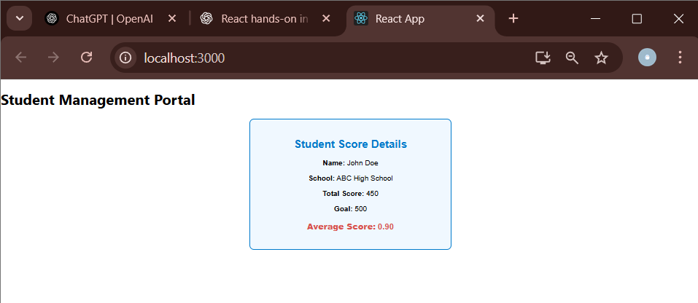

**Create a new react application using *create-react-app* tool with the name as “blogapp”**

**Installation**

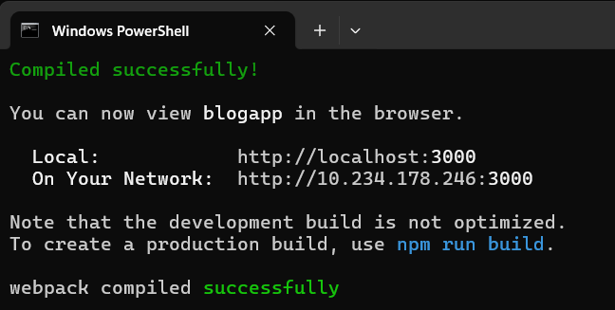

**App.js**

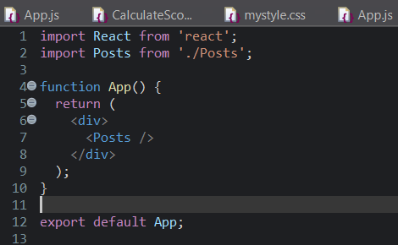

**Post.js**

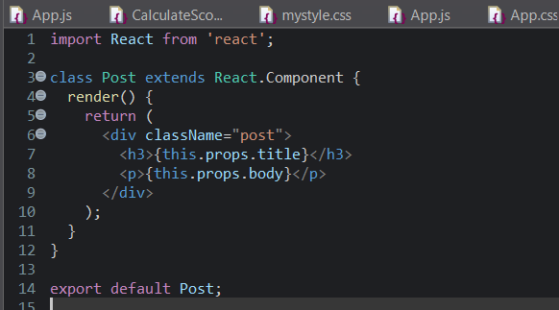

**Posts.ja**

import React from 'react';

import Post from './Post';

class Posts extends React.Component {

constructor(props) {

super(props);

this.state = {

posts: [],

hasError: false

};

}

// Fetch posts after the component mounts

componentDidMount() {

this.loadPosts();

}

// Fetch API to get posts

loadPosts() {

fetch('https://jsonplaceholder.typicode.com/posts')

.then(response => response.json())

.then(data => {

this.setState({ posts: data });

})

.catch(error => {

console.error('Error fetching posts:', error);

this.setState({ hasError: true });

});

}

// Catch any rendering errors

componentDidCatch(error, info) {

alert('An error occurred while loading posts!');

console.error(error, info);

}

render() {

if (this.state.hasError) {

return <h2>Something went wrong while loading posts.</h2>;

}

return (

<div>

<h1>Blog Posts</h1>

{this.state.posts.map(post => (

<Post key={post.id} title={post.title} body={post.body} />

))}

</div>

);

}

}

export default Posts;

**Output :**

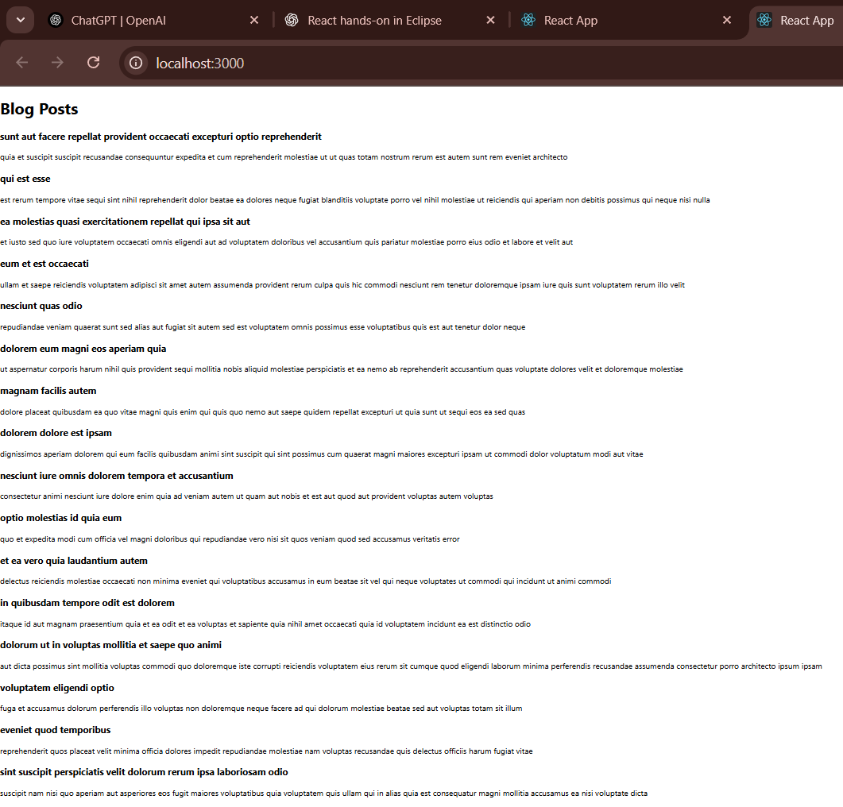

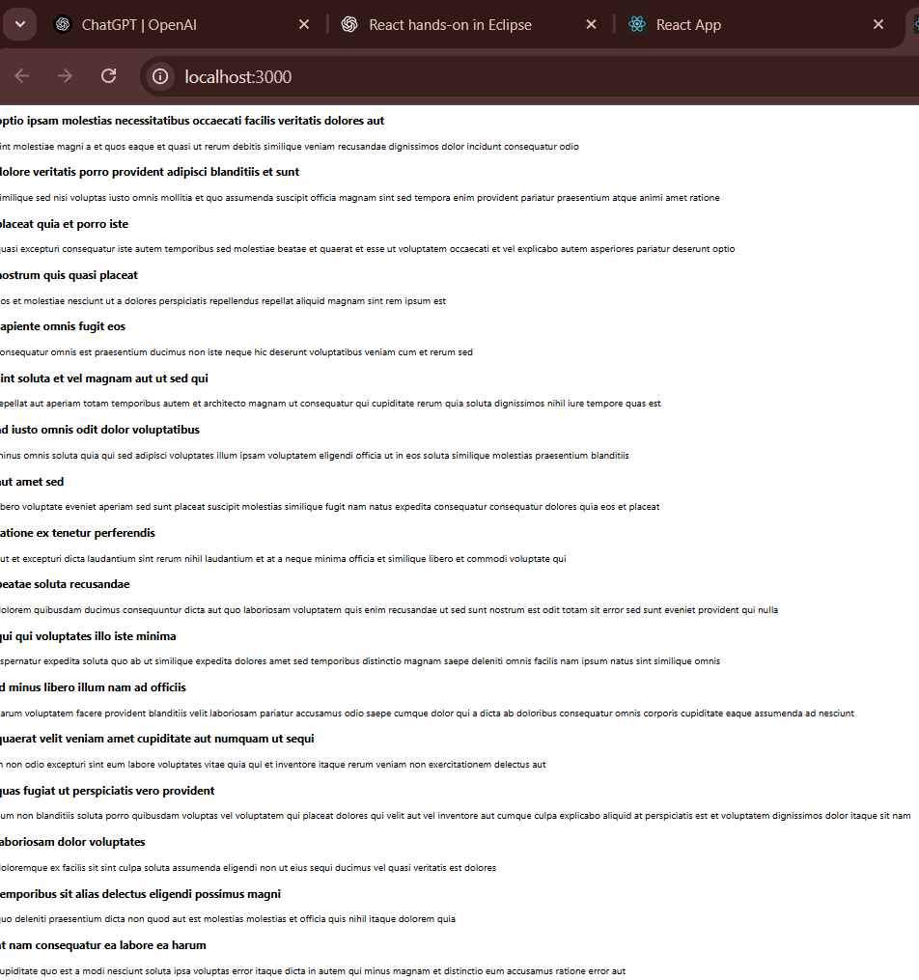

**My Academy team at Cognizant want to create a dashboard containing the details of ongoing and completed cohorts. A react application is created which displays the detail of the cohorts using react component. You are assigned the task of styling these react components.**

**Installation**

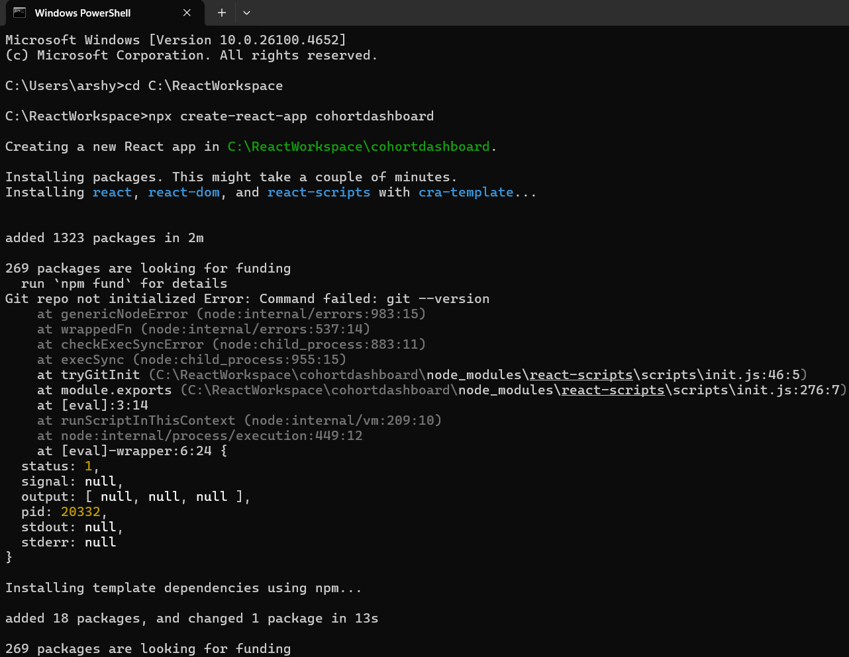

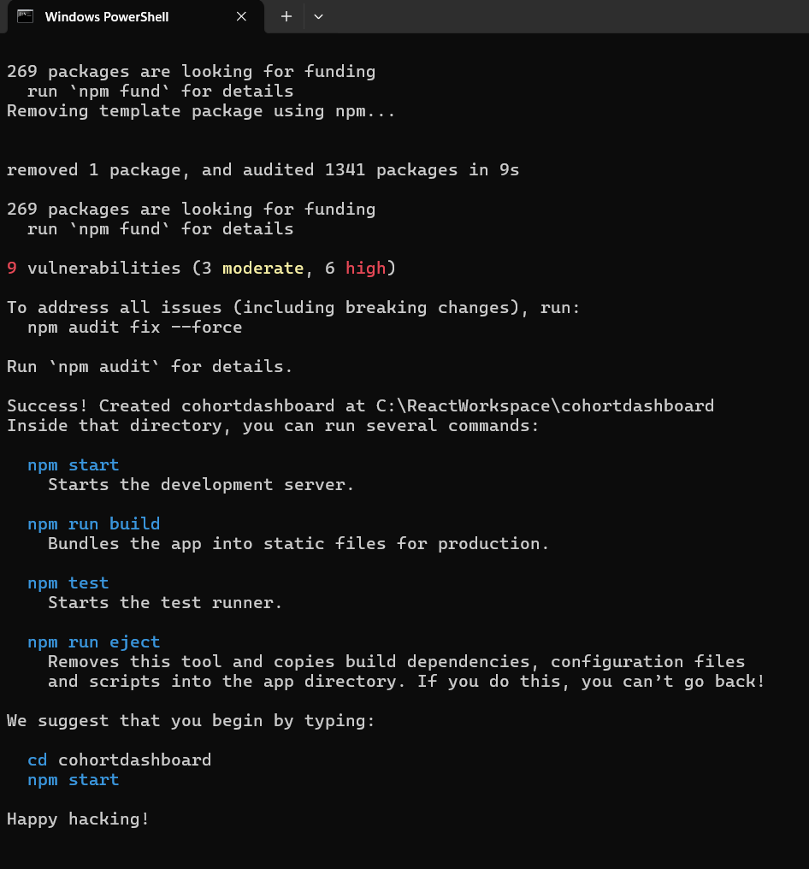

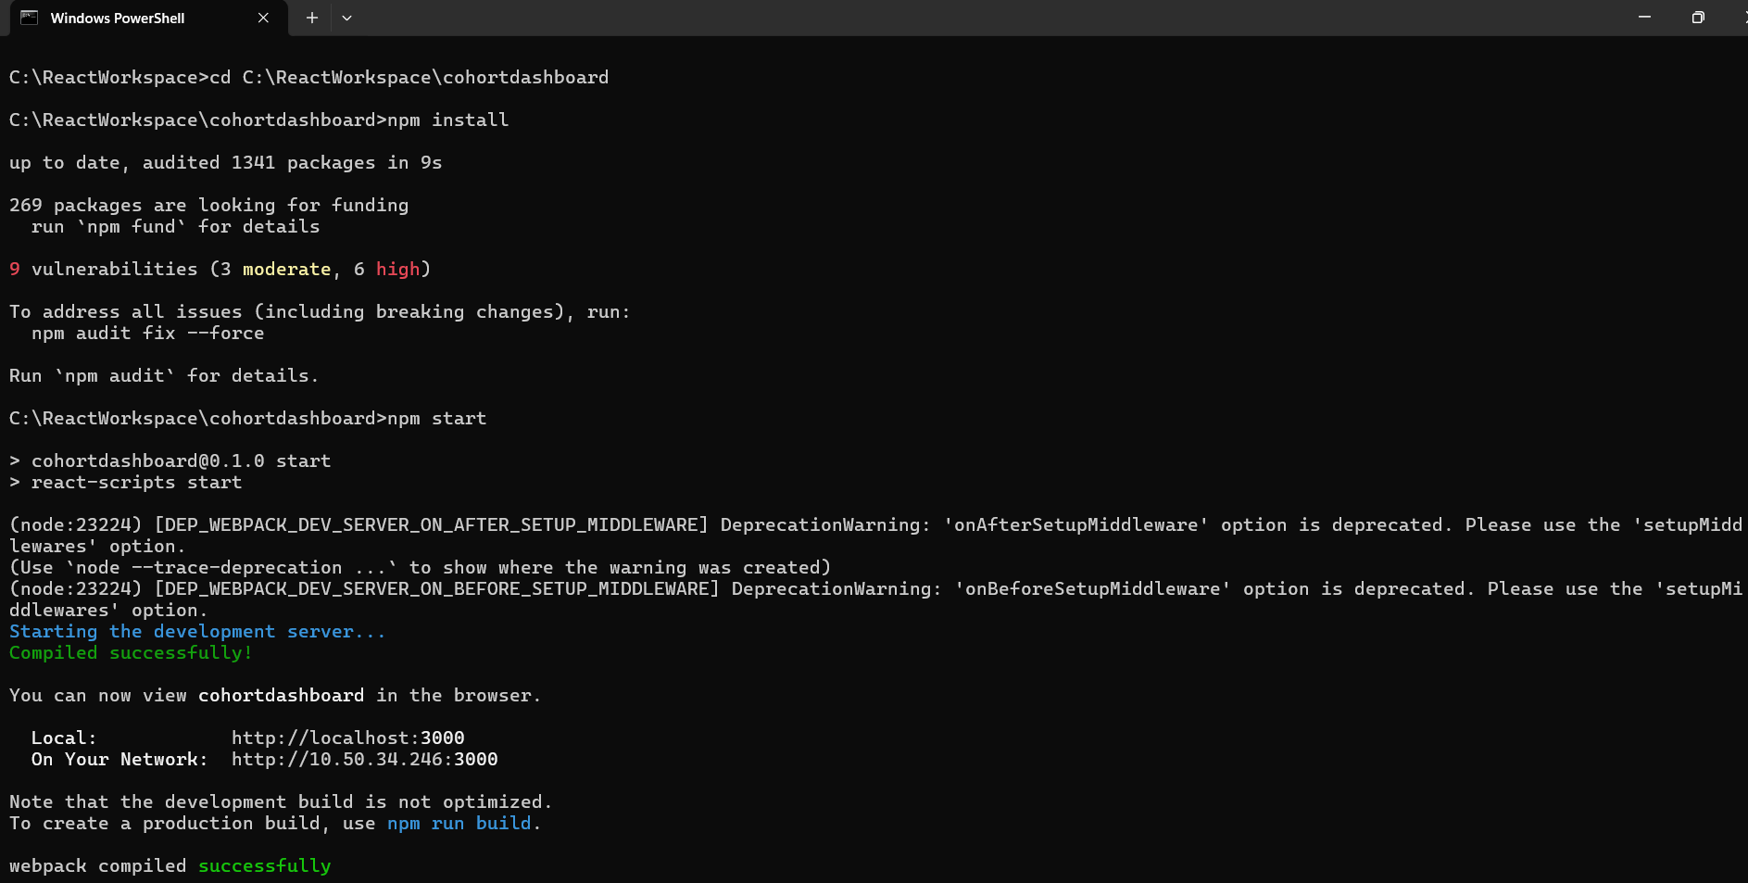

**CohortDetails.js**

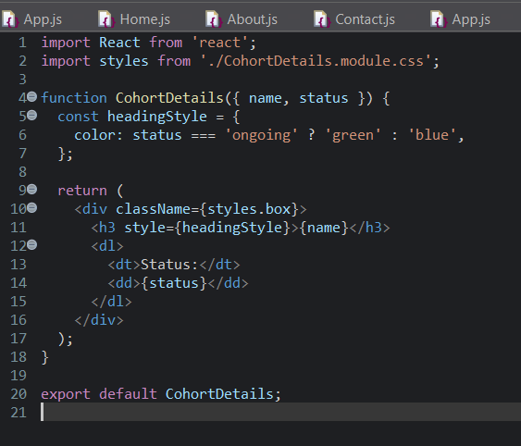

**CohortDetails.modules.css**

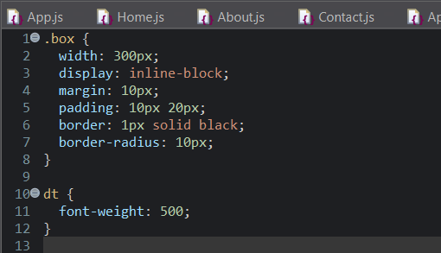

**App.js**

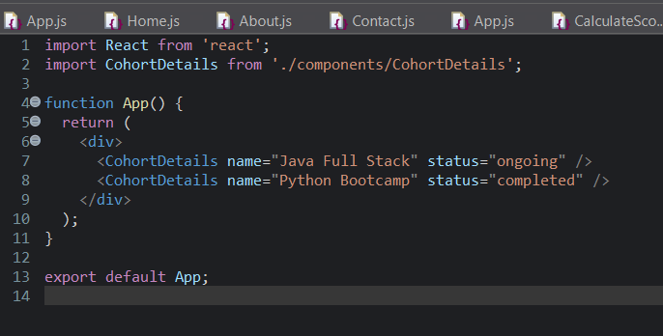

**Output :**

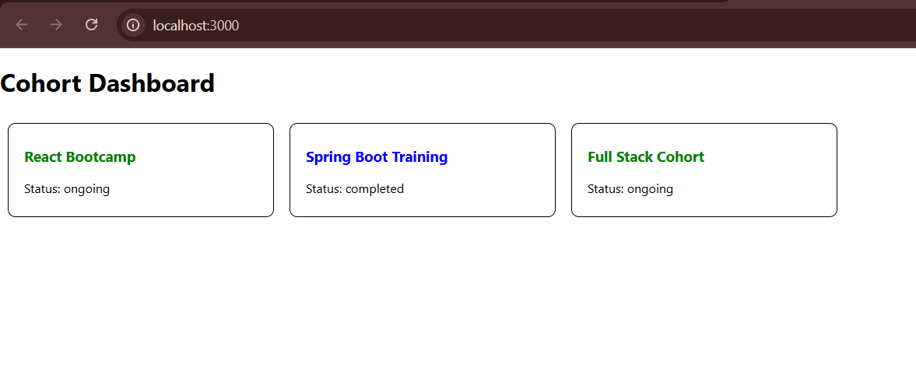

**Create a new React app using *create-react-app* tool with the as “TrainersApp”**

**Installations :**

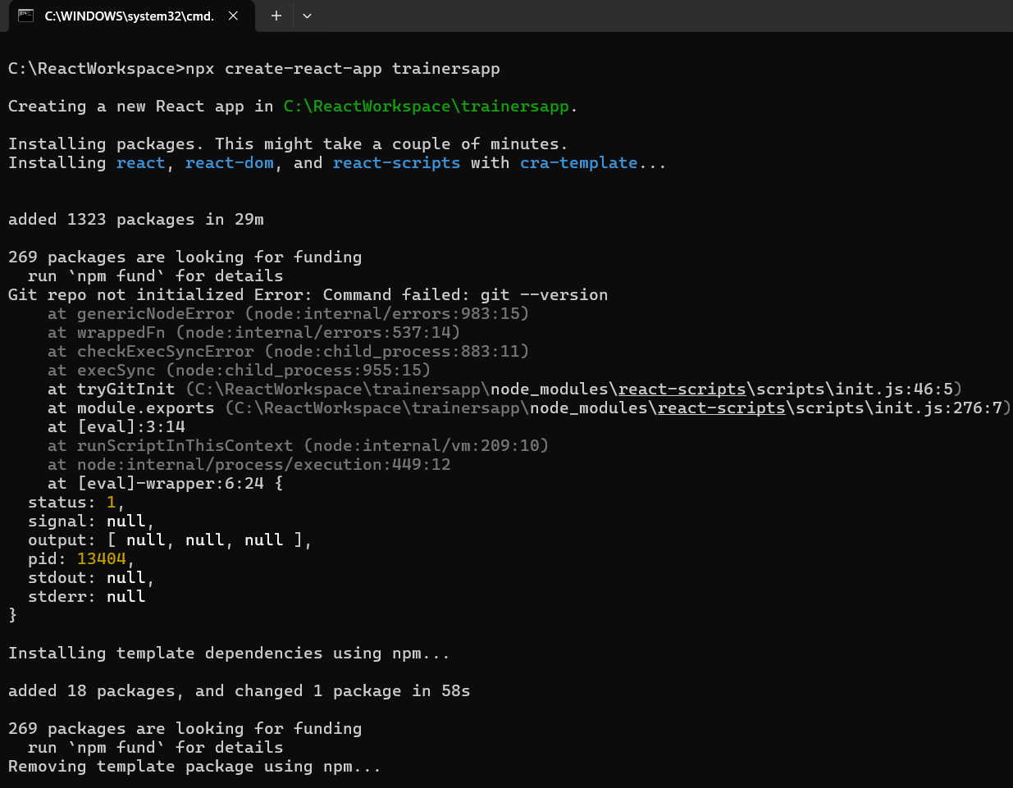

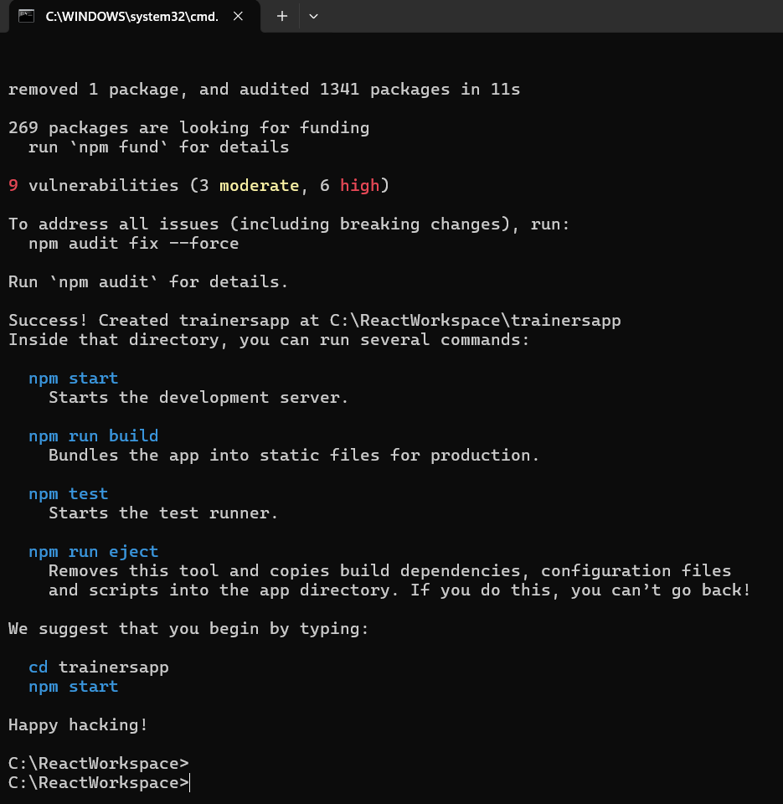

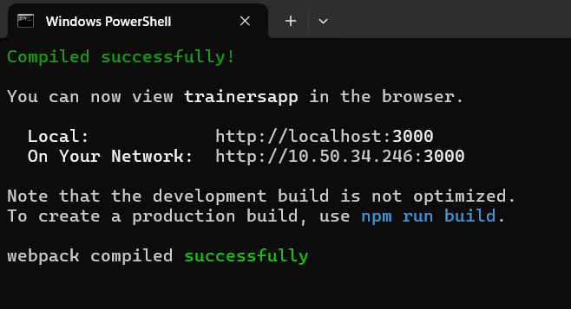

**App.js**

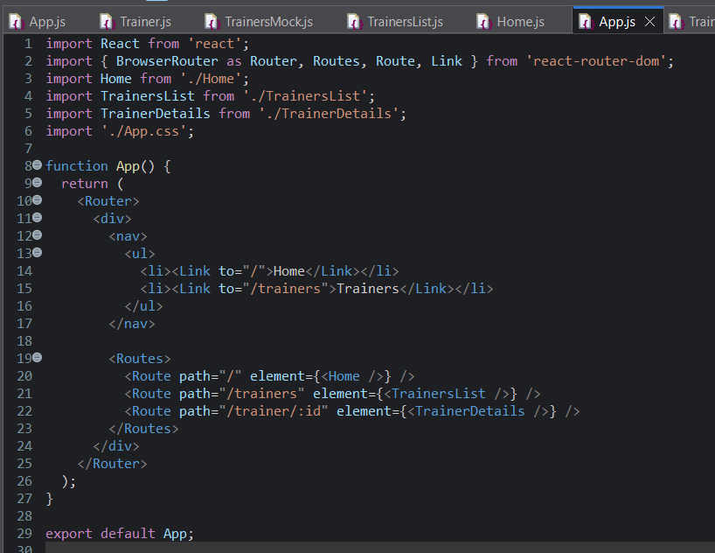

**Trainer.js**

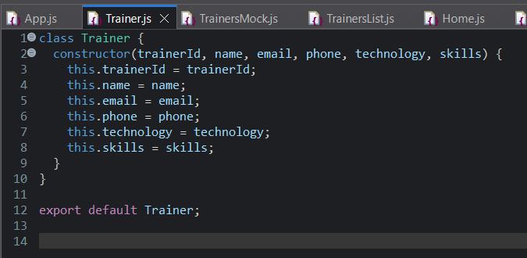

**TrainerDetails.js**

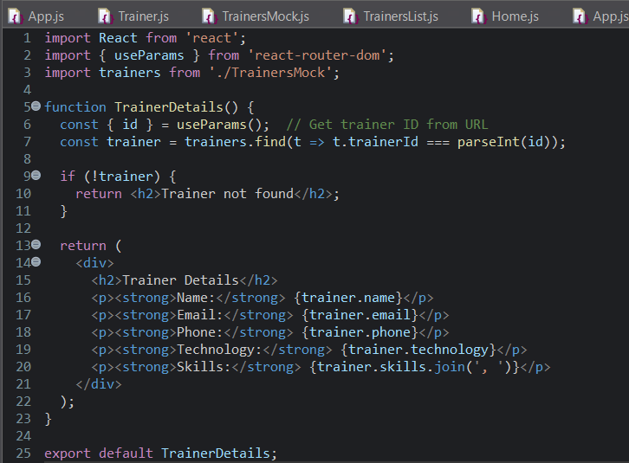

**TrainerList.js**

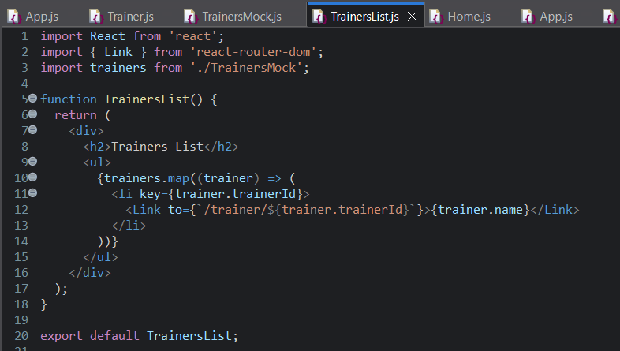

**TrainersMock.js**

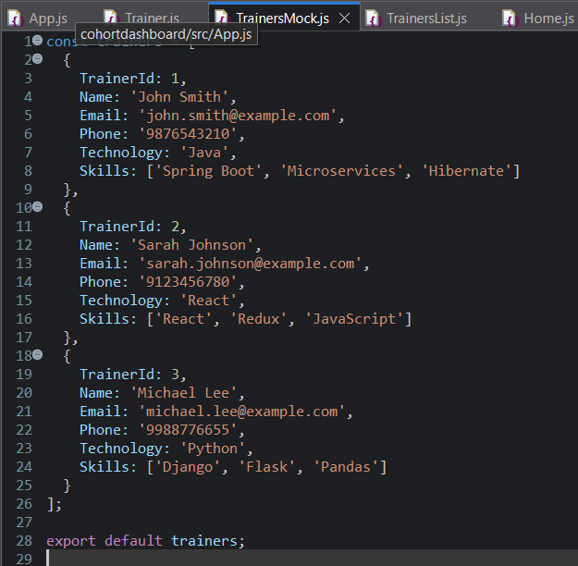

**Output :**

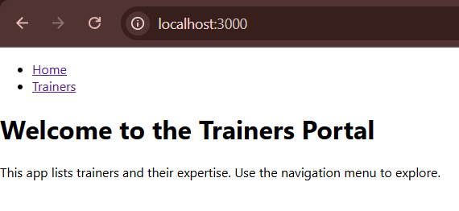

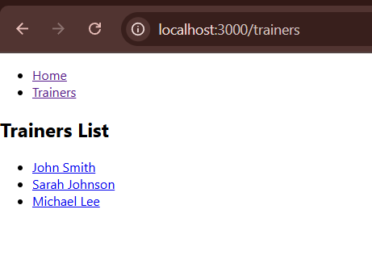

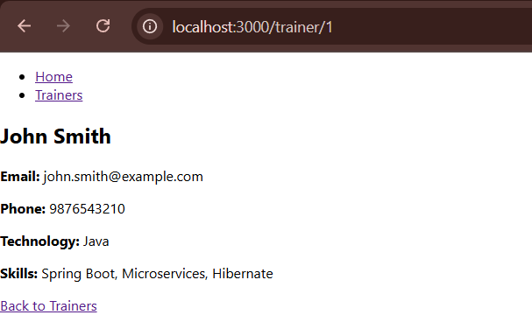

**Create a React Application named “shoppingapp” with a class component named “OnlineShopping” and “Cart”.**

**Installation**

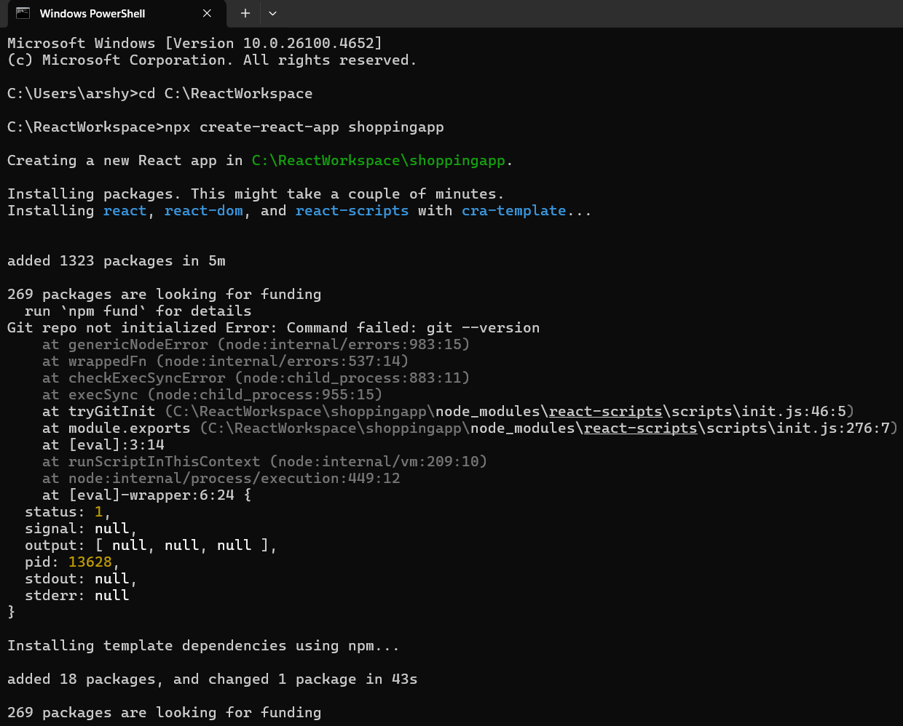

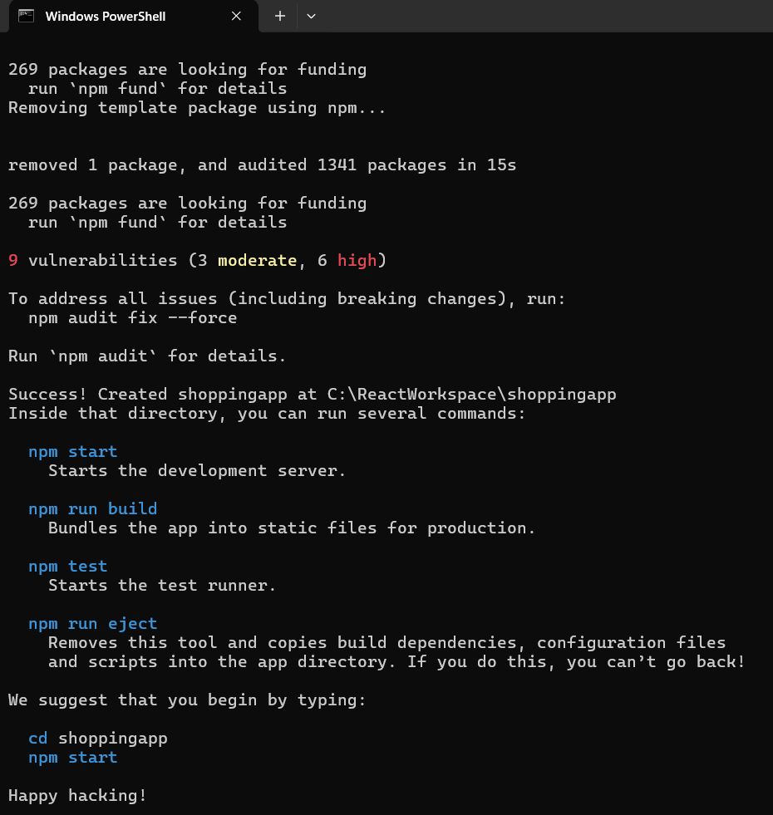

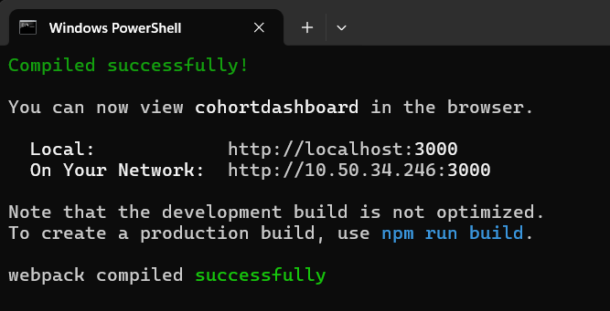

**App.js**

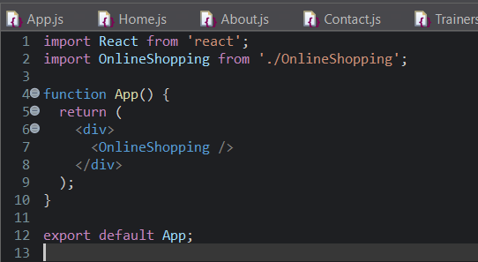

**Cart.js**

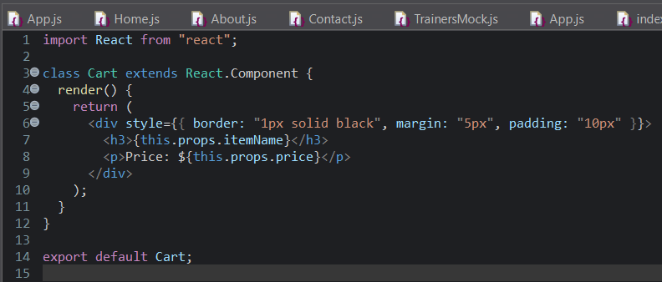

**OnlineShopping.js**

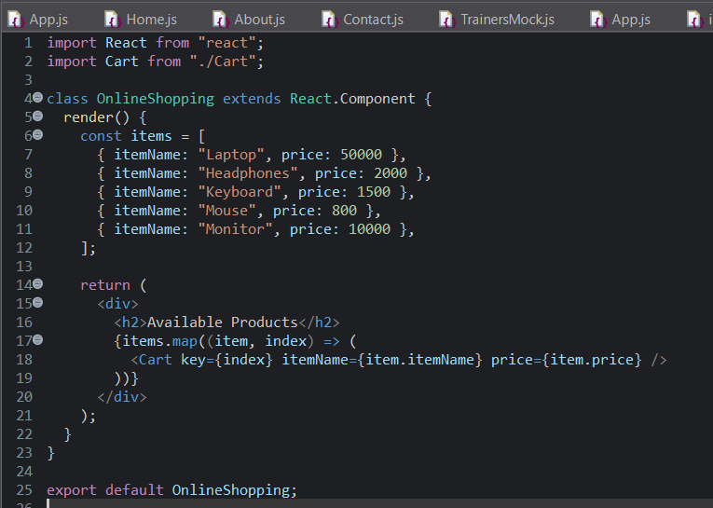

**Output :**

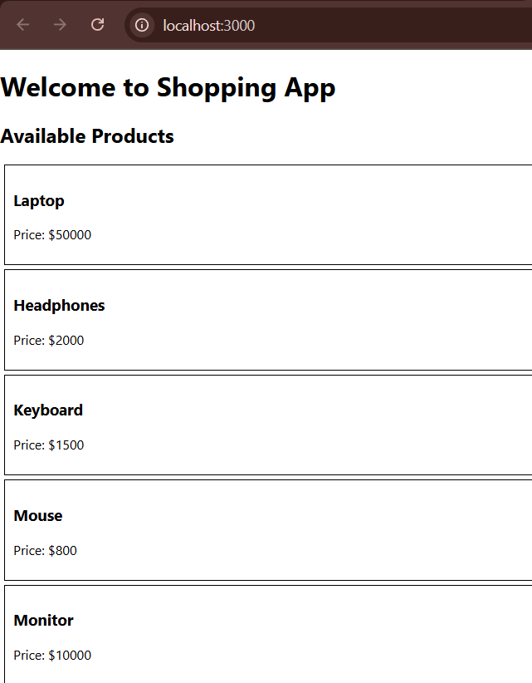

**Create a React App “counterapp” which will have a component named “CountPeople” which will have 2 methods.**

**UpdateEntry() 🡪 which will display the number of people who entered the mall.**

**UpdateExit() 🡪 which will display the number of people who exited the mall.**

**Use Constructor and state to Store the entrycount and exitcount.**

**Installation**

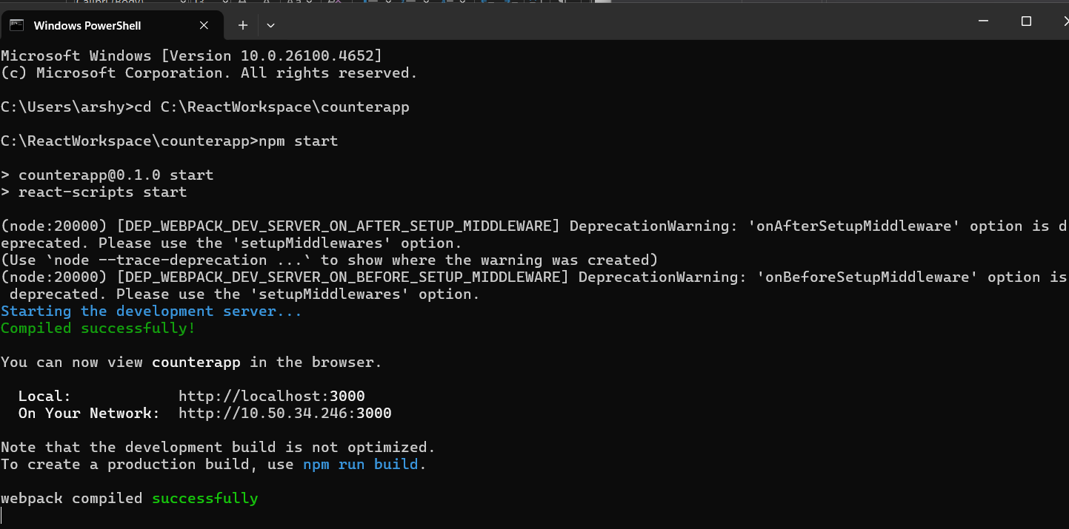

**App.js**

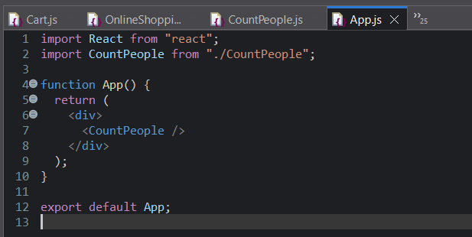

**CountPeople.js**

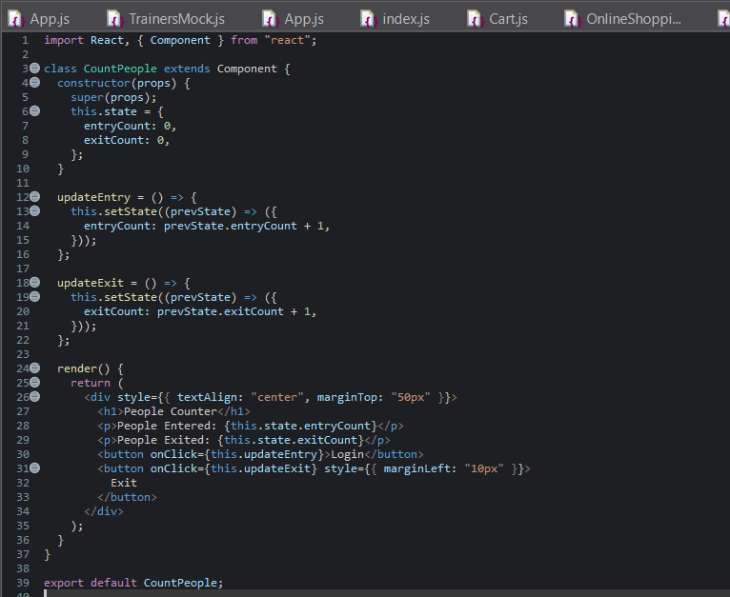

**Output :**

